Nexus between Energy, CO2, and GDP

# Introduction and background:

Every data has a story and hidden facts when analyzed, but not every story has facts and data insights. Eastern countries like India and China are often blamed for their high CO2 emissions and thereby tagged as highest polluters in the world. A recent tweet by Nikki Haley caught my attention as to what is causing diplomats to trust that there are few countries, especially the Eastern countries, contribute to higher percentage of emissions to the atmosphere. For example, a recent tweet by an American diplomat is displayed below.

Such claims are inspiration for the data set selection. I explored the past data as well as the data forecast, that is a predicted dataset by EIA until the year 2050.

As I went through the analysis, I tried to answer the following research questions.

1. Do we really have to confront India and China?

2. Is there a specific country to blame for carbon emissions?

3. Is there a relationship between energy consumption and economic activity?

# Datasets

The ‘Organisation for Economic Co-operation and Development (OECD)’ which is an international organisation that works to build better policies for better lives, as a part of its statistical data collection, has predicted measures like energy consumption, carbon emissions, population etc. for the span from 2020 to 2050 using historical data. This caught my attention while searching for energy related datasets and has set the aim to explain these projections to the audience as to how the increase in the energy consumption in the form of renewable and non-renewable energy resources is going to impact carbon emissions for different countries and regions. On the parallel lines I want to correlate and explore the GDP and population growth data and explain the audience of the upcoming trends of energy usage and its correlation with GDP, Carbon dioxide emissions and population.

|  |  |
| --- | --- |
| **Variables** | **Units** |
| Primary energy consumption by region | quadrillion British thermal |
| Total energy consumption by region and fuel | quadrillion British thermal |
| World gross domestic product (GDP) by region expressed in purchasing power parity | billion 2015 dollars |
| World gross domestic product (GDP) by region expressed in market exchange rate | billion 2015 dollars |
| World liquids consumption by region | million barrels per day |
| World natural gas consumption by region | trillion cubic feet |
| World coal consumption by region | million short tons |
| World nuclear energy consumption by region (net nuclear electricity generation) | billion kilowatt-hours |
| World consumption of hydroelectricity and other renewable energy by region | quadrillion British thermal units |
| World carbon dioxide emissions by region | million metric tons carbon dioxide |
| World carbon dioxide emissions from liquids use by region | million metric tons carbon dioxide |
| World carbon dioxide emissions from natural gas use by region | million metric tons carbon dioxide |
| World carbon dioxide emissions from coal use by region | million metric tons carbon dioxide |
| World population by region | million persons |
| Gross output by region and sector | billion 2015 dollars |

After performing a certain level of analysis, I realized the need to explore not just the predictions but also historical data for the variables CO2 emissions, GDP, Energy Usage. The following data set provides information starting from the year 1750 to 2021 which is taken from Our world in data.

|  |  |  |
| --- | --- | --- |
| **Historical CO 2 Emissions** | **Historical GDP** | **Historical Energy use** |
| Country | Country | Country |
| Year | Year | Year |
| Population | Population | Population |
| Annual CO2 emissions per capita | GDP per capita, PPP | Primary energy consumption per capita |

In the process, I had some calculated variables namely per capita primary energy consumption, per capita carbon emissions and energy intensity.

Data Limitation: Although CO2 emissions explain a major part of pollution, there are some other types of pollutants that can contribute to climate change like CFCs, CO etc. which are not a part of current data analysis.

# Data Story

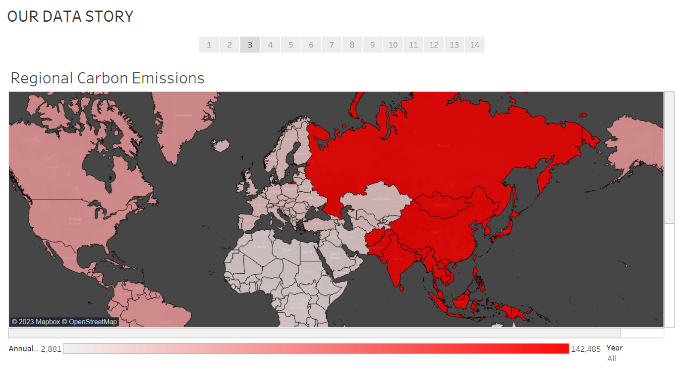

Initially while analyzing regional data for carbon emissions, a pattern of highest carbon emissions that is 142,485 million metric tons is found in the Eastern/Asian region of the world which conventionally support most claims of developed countries about the developing countries of Asian region. The entire American region accounts to only one thirds of the total emissions from Asia. The European union contributes only one sixth of Asia’s CO2 emission Volume.

**Tableau technique** – Groups of countries is executed following the below reference <https://help.tableau.com/current/pro/desktop/en-us/sortgroup_groups_creating.htm>

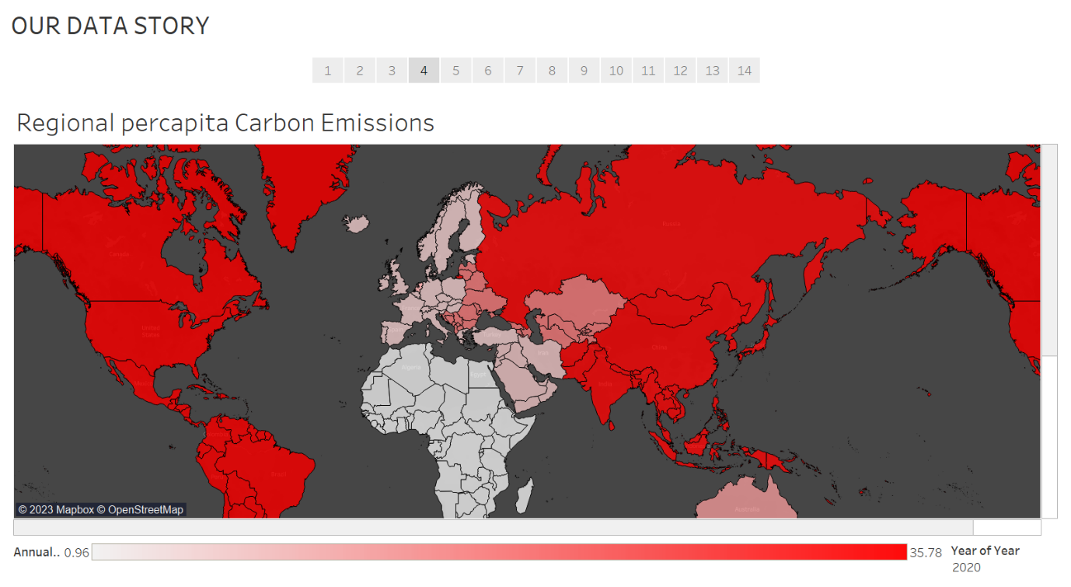

When a calculated field of ‘Per capita carbon emissions’ is introduced, a different world order is seen. An average Asian produces 34.65 metric tons of CO2 per year while and average person per American continents produces 35.78 metric tons of CO2 per year.

**Tableau technique** – A calculated field called per capita CO2 emissions is created using the formula, *[Carbon dioxide emission (Million Metric Tons)]/ [Population by region (Millions)]*

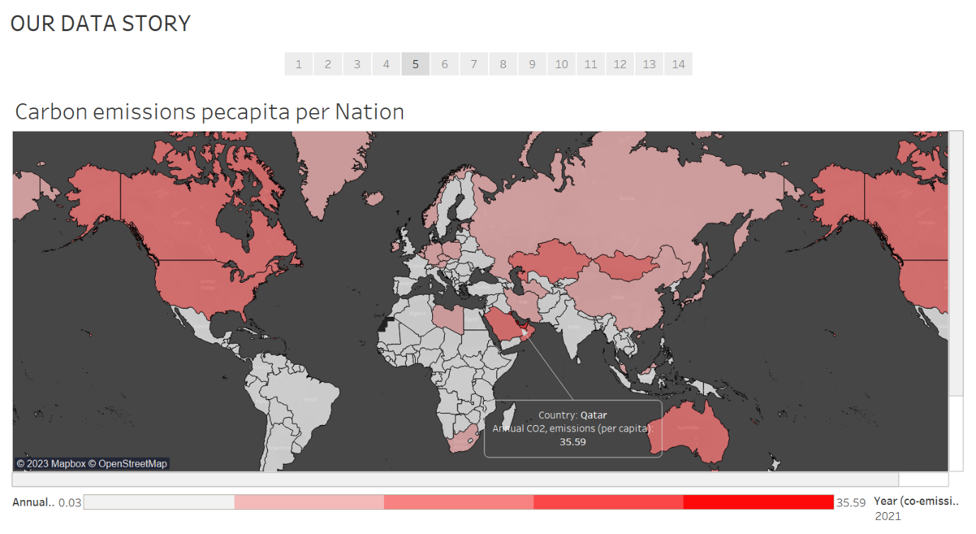

To dig deeper into an analysis of each country per capita Carbon dioxide emissions, a historical data set is connected to the tableau file that has records starting from 1750 to 2010 and a pattern that evidently shows the emerging analytical proof that there are many developed countries that claim Asia is the most polluting region, or at least the initial data set that evidently showed a high volume of CO2 emissions, are producing higher levels of per capita carbon emissions. An average person in the USA produces at least 12times as much as an average Indian and 1.5 times that of a Chinese citizen does produce. The reason from my research shows that there are considerably many factors including higher average number of devices used per person, high standards of living, consumerism etc. according to a report by McKinsey. <https://www.mckinsey.com/industries/electric-power-and-natural-gas/our-insights/the-decoupling-of-gdp-and-energy-growth-a-ceo-guide>

**Tableau technique** – Three new data sets added by connecting them to a pivoted data created by us.

Annotations referenced from <https://help.tableau.com/current/pro/desktop/en-us/annotations_marklabels_showhideworksheet.htm>

This box plot further explains the extent to which Gulf country per capita carbon emissions are ranging.

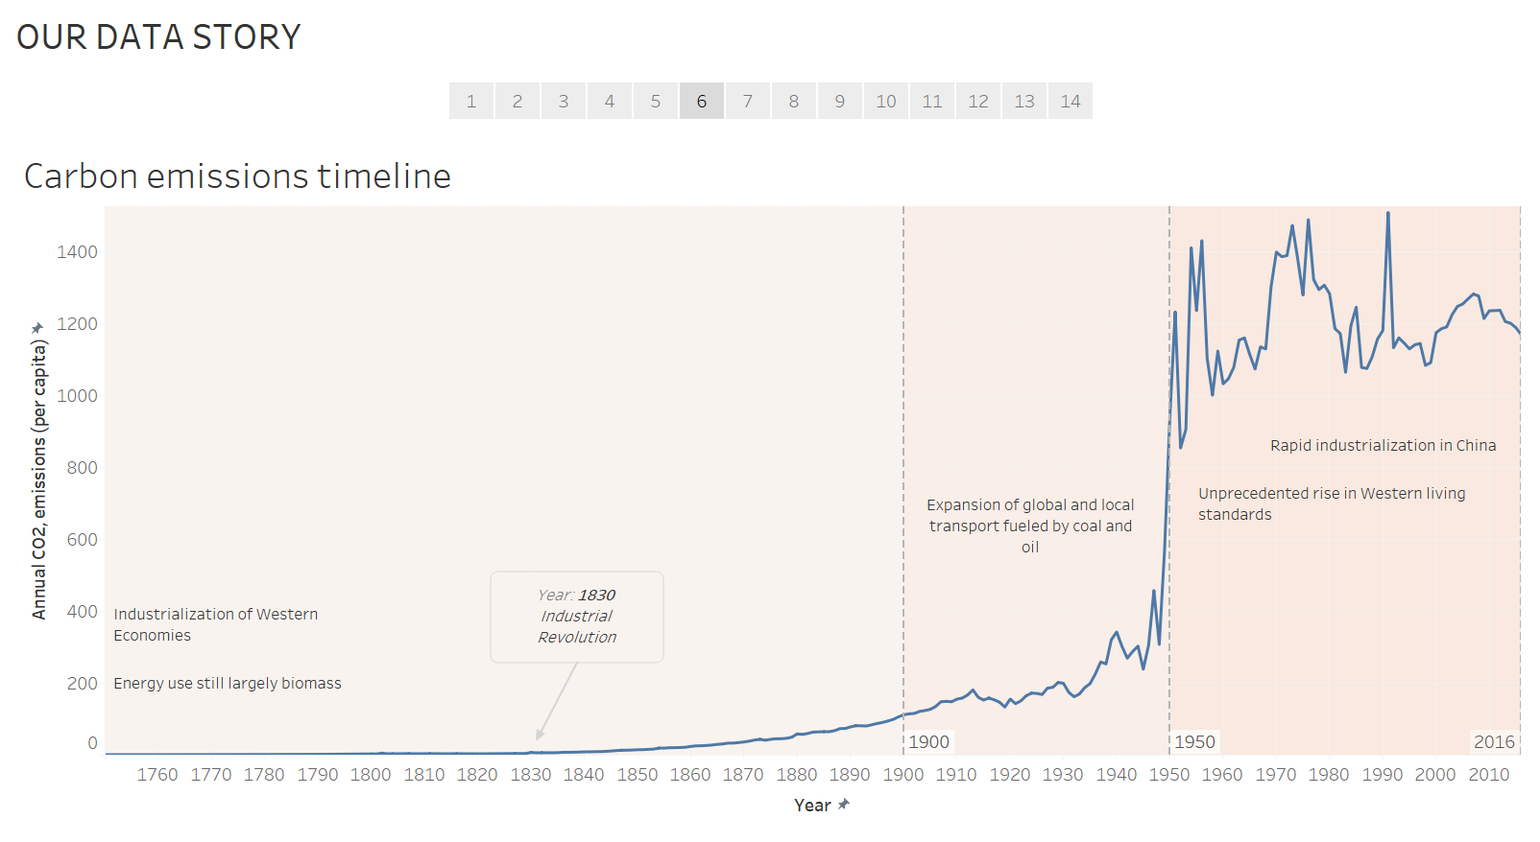

To summarize the above graph, the unprecedented rise in Western living standards during mid 1900s has caused the greatest ever leap in CO2 emission.

Tableau technique – Reference bands for analysis intervals from 170 to 1900, 1900 to 1950, 1950 to 2016

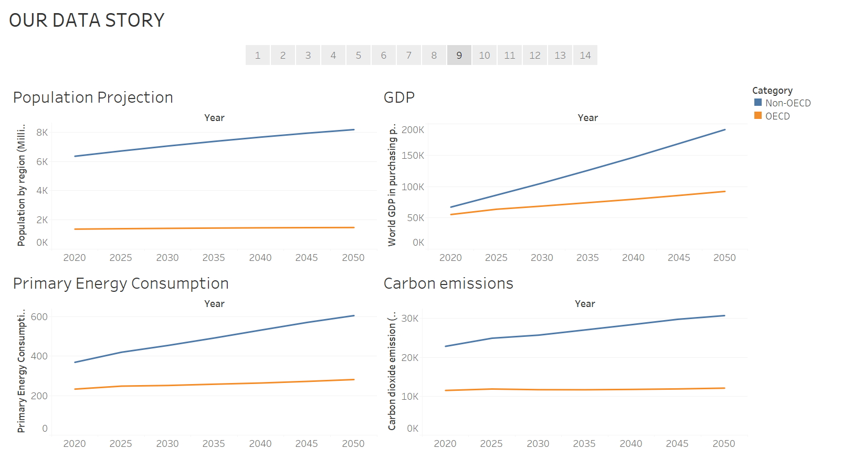

With almost a flat population graph, and already low population, numbers can be deceiving enough to conclude like I spoke about in the introduction of the report paper that a set of OECD countries have low energy consumption or low carbon emissions. While they have the highest per capita energy consumption and CO2 emission values, historically, the developed countries should give a careful thought of non-aggregated numbers as well.

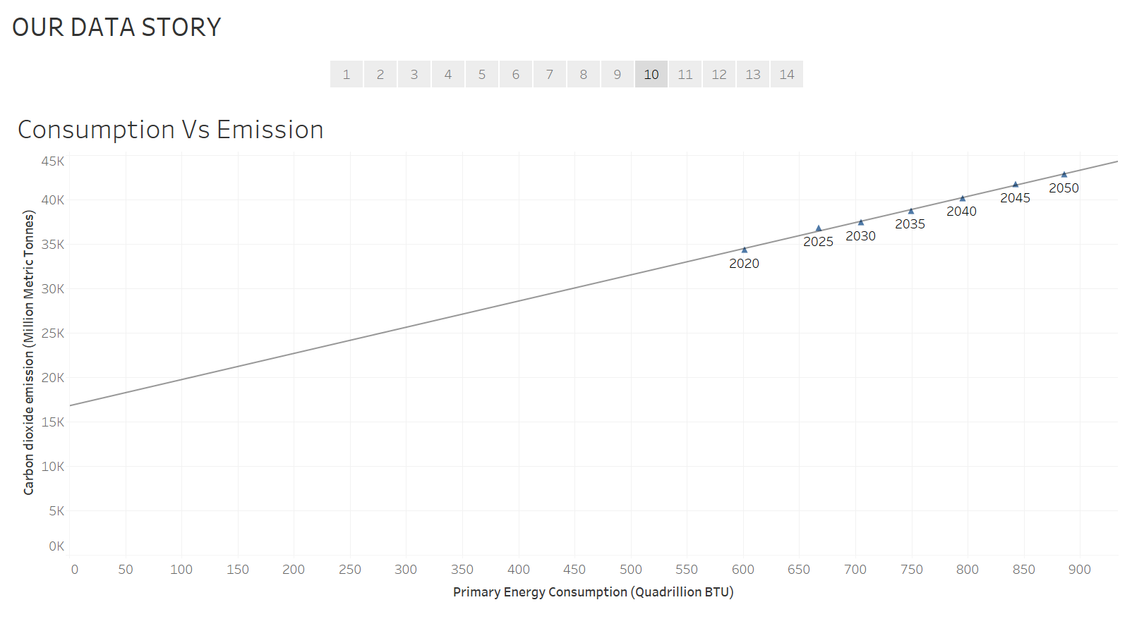

This energy demand curve needs to flatten with advent of technology. Parallelly each unit of energy consumed should emit lesser CO2 in the upcoming years. Because the energy demand is going to increase as the population grows and as the economies grow. This concept explained by creating a calculated field in the following Energy intensity graph. So, the best practise is to improve technologies that require less energy.

Tableau Technique – Trendline, R square- 0.99

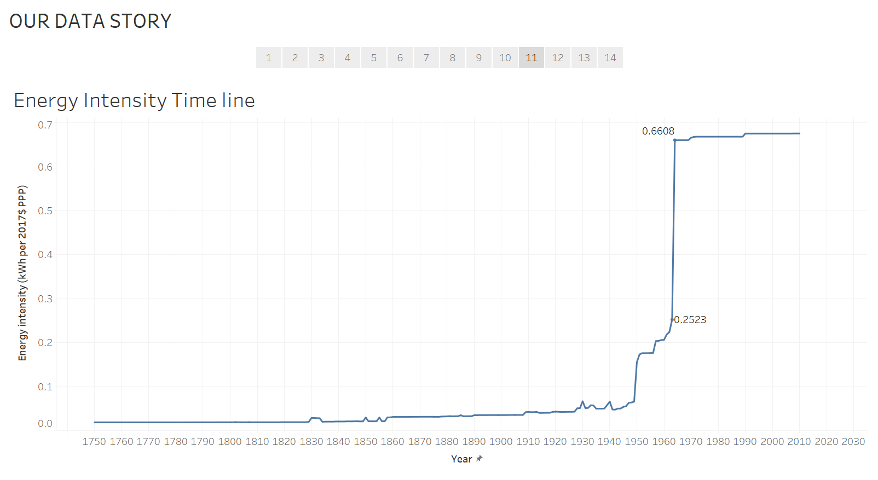

A steepening curve for an energy intensity timeline is a positive indication (referred from <https://en.wikipedia.org/wiki/Energy_intensity> ) . As the current energy intensity of the world does not have a steepening curve, efforts need to be made in research different aspects of each country like standards of living, energy efficiency of infrastructure, mass transit, etc.

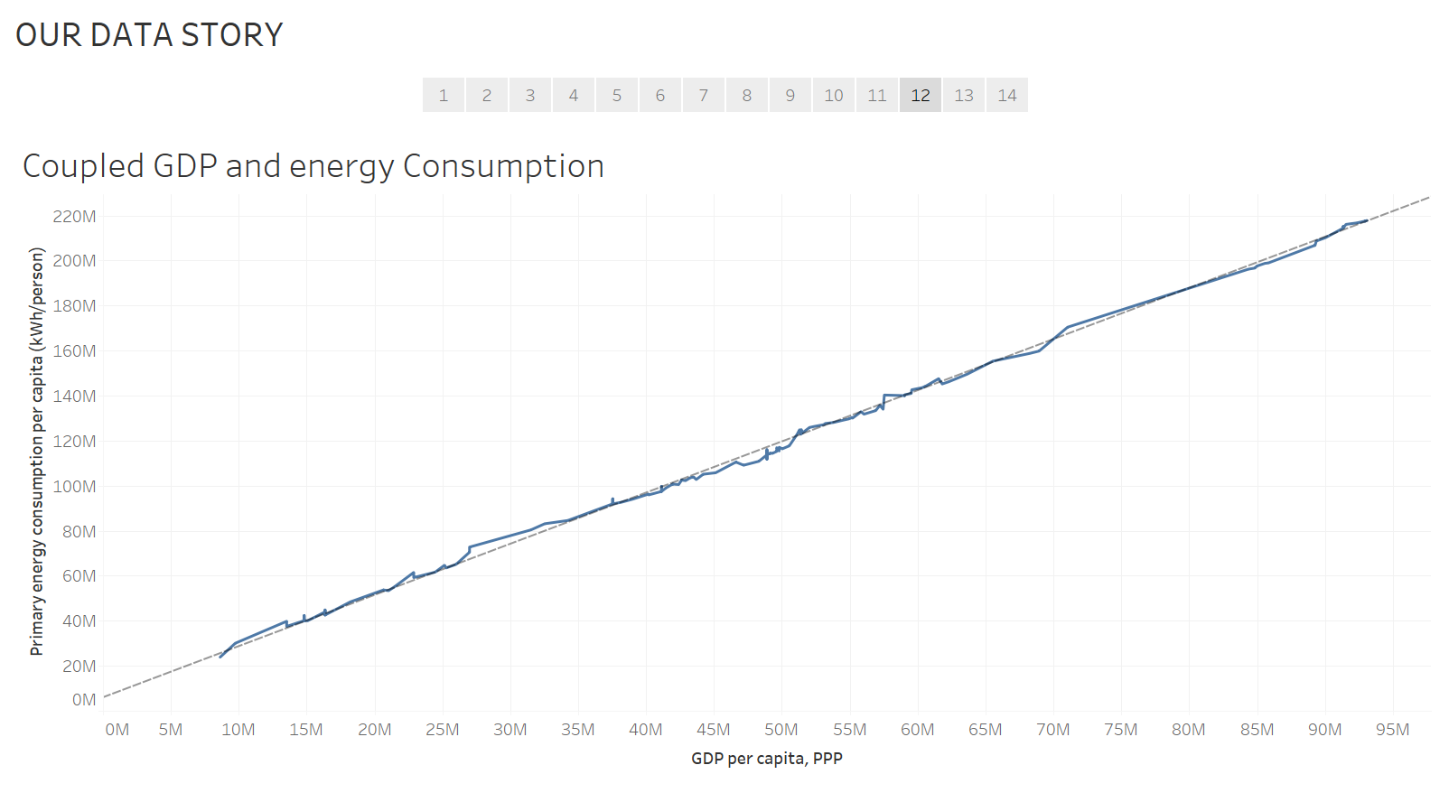

The linearity of the trendline shows the dependability of emissions on the amount of energy consumption which is mostly of non-renewable energy which directly emphasizes the need for the development of renewable energy resources and improvement in technology that enables less energy consumptions to reduce the connection between energy and GDP. The reference is taken from the following website to explain the visualization better <https://help.tableau.com/current/pro/desktop/en-us/trendlines_add.htm>, <https://www.imf.org/external/pubs/ft/fandd/2007/03/basics.htm>

Tableau technique – Trendline

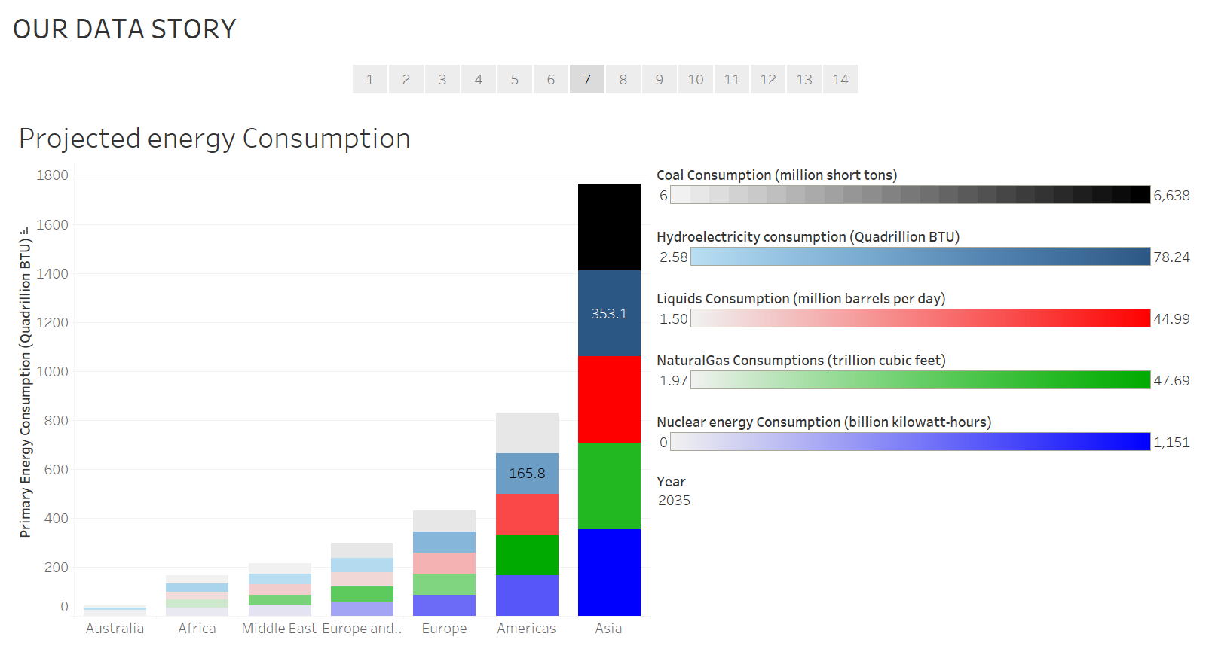

An increasing trend for hydroelectricity can be seen in Asia which indicates its own effort for developing renewable sources of energy.

Tableau technique – Multiple Measure values.

# Summary and Conclusions

There is no specific country or region to completely put blame on according to the analysis in the first half of the story because the second half of the story does not show the following trends:

The world doesn’t show a steep decline in energy intensity and a marked increase in energy efficiency and improved use of renewable resources. So, before any of the above trends is achieved by all the world countries, a particular country cannot blame another country because of the following factors:

We cannot compare Industry oriented and highly populated eastern world and service oriented and less populated western world.

Decoupling energy demand from economic growth

A steep decline in energy intensity of GDP - primarily the consequence of a continuing shift from industrial to service economies in fast-growing countries such as India and China

A marked increase in energy efficiency - the result of technological improvements and behavioral changes

The rise of electrification- a more efficient way to meet energy needs in many applications.

The growing use of renewables - resources that don’t need to be burned to generate power—a trend with the potential not only to flatten the primary energy demand curve but also to utterly change the way we think about power.

# References

1. <https://www.eia.gov/outlooks/ieo/pdf/appm.pdf>
2. EIA, World Energy Projection System (2021)
3. <https://www.eia.gov/outlooks/aeo/tables_ref.php>
4. <https://www.imf.org/en/Publications/fandd/issues/Series/Back-to-Basics/Purchasing-Power-Parity-PPP>
5. [Gross Domestic Product: An Economy’s All](https://www.imf.org/-/media/Files/Publications/Fandd/Back-to-Basics/callen-gdp.ashx)
6. <https://www.epa.gov/energy>
7. <https://www.google.com/publicdata/explore?ds=lp1a8c08eee7i_&ctype=l&met_y=coal_consumptionpc&idim=oecd:nOECD:OECD#!ctype=l&strail=false&bcs=d&nselm=h&met_y=hydro_consumption&scale_y=lin&ind_y=false&rdim=oecd&idim=oecd:nOECD:OECD&ifdim=oecd&hl=en_US&dl=en_US&ind=false>
8. <https://www.mckinsey.com/industries/electric-power-and-natural-gas/our-insights/the-decoupling-of-gdp-and-energy-growth-a-ceo-guide>
9. <https://en.wikipedia.org/wiki/Energy_intensity>
10. <https://ourworldindata.org/>